Oaxis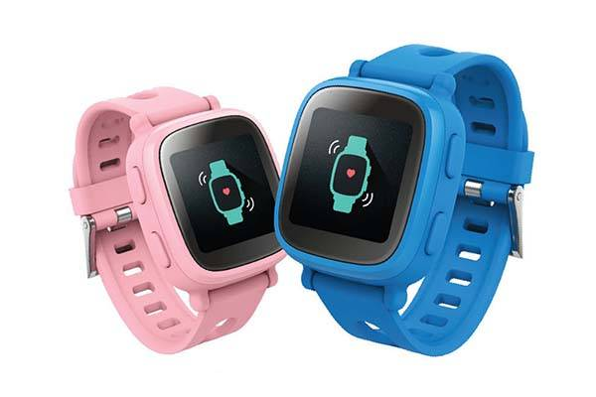

Description: **Oaxis** is a tech brand known for offering innovative **smartwatches** and **wearable devices** that combine **modern technology**, **health monitoring**, and stylish designs. Oaxis focuses on delivering practical and affordable smartwatches for various lifestyles, with a particular emphasis on fitness, wellness, and convenience. Their wearables are known for being **sleek**, **user-friendly**, and equipped with essential features that cater to both casual users and fitness enthusiasts.

One of the brand's standout products is the **Oaxis Timepiece** series, which combines classic watch designs with **smart capabilities**. These watches often feature **touchscreen displays**, **fitness tracking** (such as **step counting, heart rate monitoring, and sleep tracking**), and the ability to sync with **smartphones** for notifications and app alerts. Some models offer a **hybrid design**, where the traditional analog watch face is combined with smart features that track activity and display essential information like time, steps, and call alerts.